**☁️ Cloud vs. On-Premise Hosting 🏢**

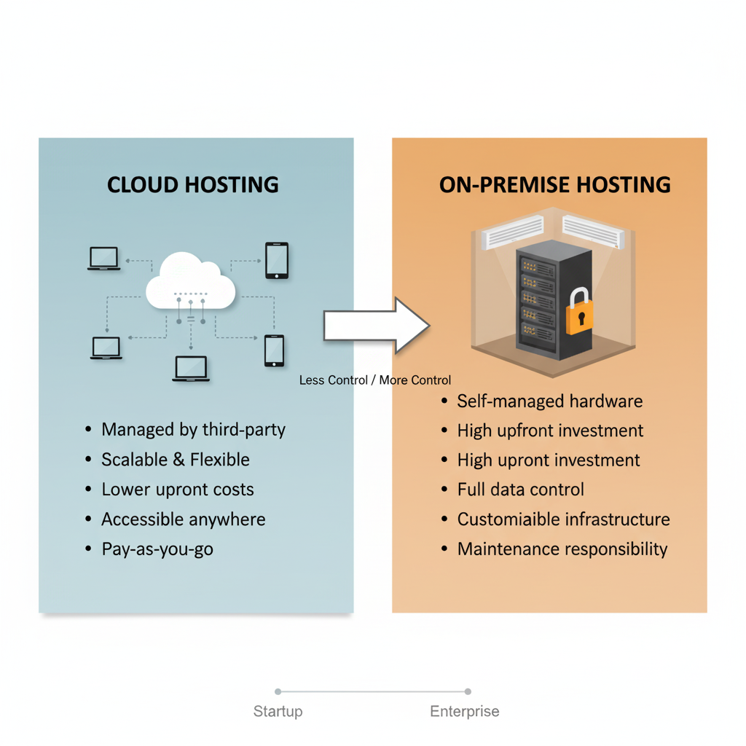

**On-Premise Hosting**

This is the traditional model where a company purchases its own servers and IT infrastructure and houses it within its own facilities. You are responsible for everything from the physical security of the hardware to the maintenance and updates of the software.

* **Analogy:** Owning a house. You have complete control over the property, but you are also responsible for all maintenance, security, and repairs.
* **Best for:** Organizations with strict regulatory or security requirements, legacy applications that are difficult to migrate, or those who need maximum control over their hardware and data.

**Cloud Hosting**

This model involves renting computing resources (like servers, storage, and networking) from a third-party provider (like Amazon Web Services, Google Cloud, or Microsoft Azure). You access these resources over the internet.

* **Analogy:** Renting an apartment. You don't own the building, but you get to use the space and amenities without worrying about maintenance, security, or property taxes. You can easily move to a bigger or smaller apartment as your needs change.
* **Best for:** Businesses of all sizes that value flexibility, scalability, and want to avoid large upfront capital expenses on hardware.

**Key Differences:**

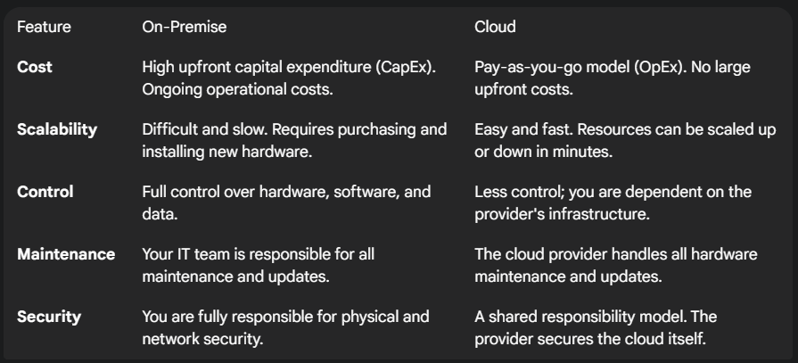

**Cloud Hosting Techniques ☁️**

Cloud hosting isn't a one-size-fits-all solution. It's offered in different layers of service, commonly known as IaaS, PaaS, and SaaS.

**🏗️ IaaS (Infrastructure as a Service)**

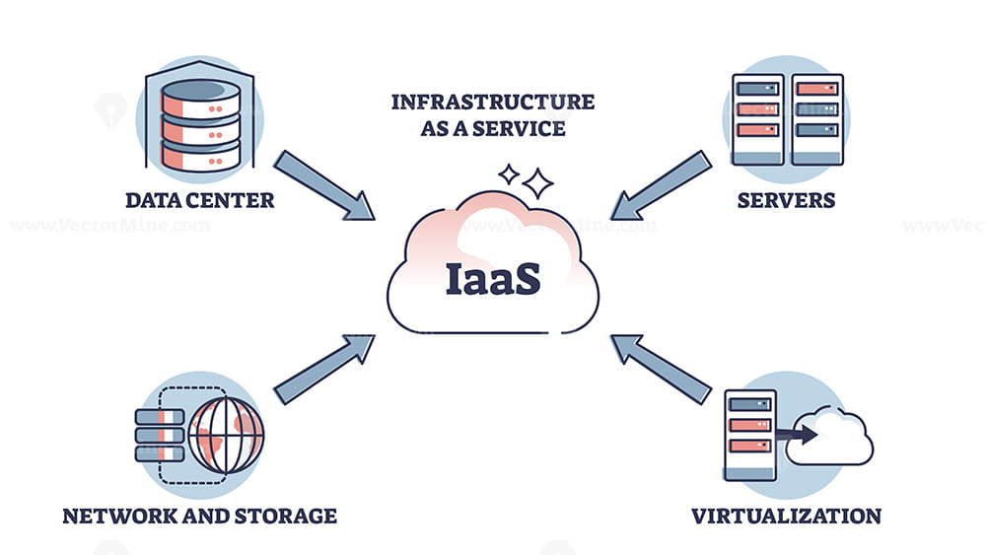

**This is the most basic cloud service model. The provider gives you access to fundamental computing infrastructure—servers, storage, and networking—over the internet. You are still responsible for managing the operating system, applications, and data.**

* **What you manage: Applications, Data, Runtime, Middleware, Operating System.**
* **What the provider manages: Virtualization, Servers, Storage, Networking.**
* **Analogy: Leasing a plot of land with utilities connected. You have to build your own house (install the OS), furnish it (deploy middleware), and live in it (run your apps).**
* **Examples: Amazon Web Services (AWS) EC2, Google Compute Engine (GCE), Microsoft Azure Virtual Machines.**

**🛠️ PaaS (Platform as a Service)**

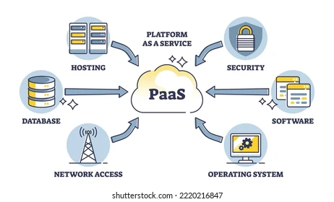

**PaaS builds on top of IaaS. The provider manages the hardware and the operating system, giving you a "platform" or environment where you can develop, test, and deploy your applications without worrying about the underlying infrastructure. This is aimed primarily at developers.**

* **What you manage: Applications, Data.**
* **What the provider manages: Runtime, Middleware, OS, Virtualization, Servers, Storage, Networking.**
* **Analogy: Renting a fully equipped workshop. All the tools and machinery (runtime, OS) are provided and maintained for you. You just bring your raw materials (code) and build your product (application).**
* **Examples: Heroku, Google App Engine, AWS Elastic Beanstalk.**

**📧 SaaS (Software as a Service)**

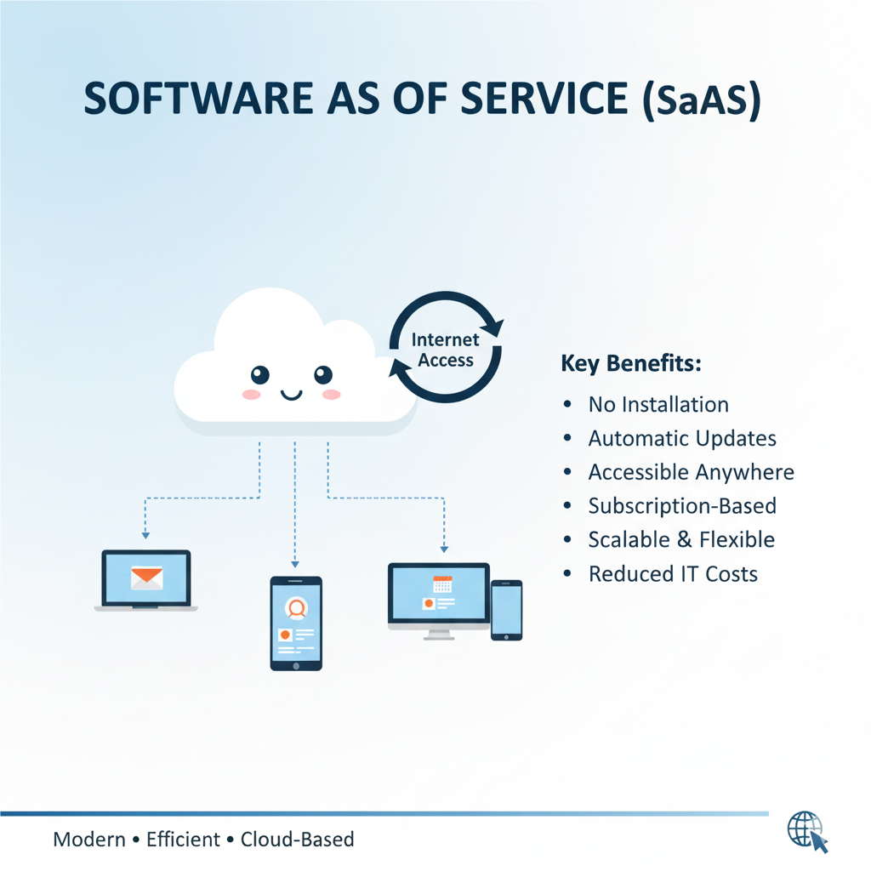

**This is the most comprehensive cloud service model. The provider delivers a complete, ready-to-use software application over the internet, typically on a subscription basis. You don't manage any part of the infrastructure; you simply log in and use the software.**

* **What you manage: Nothing. You just use the software.**
* **What the provider manages: Everything from the application down to the physical servers.**
* **Analogy: Moving into a fully furnished, all-inclusive apartment. Everything—the building, the furniture, the utilities, the cleaning service—is managed for you. You just show up with your suitcase and live there.**
* **Examples: Google Workspace (Gmail, Google Docs), Microsoft 365, Salesforce, Dropbox, Netflix.**

**Table:**

